Walls of Hope/ Ciudad Juarez, México

“ART AGAINST BRUTALITY, Walls of Hope, Ciudad Juarez, Mexico” in partnership with The International Commission of the Red Cross ICRC was possible thanks to a Transnational Cultural Remittances (TCR) Grant from the National Association of Latino Arts and Cultures NALAC.

My arrival to Ciudad Juarez was by landing from San Francisco into El Paso, Texas. The desert is vast and it seems to extend forever. Yellow impregnates people’s contours. The temperatures reach over 100 degrees, a wave of reality to which one needs to accustom fast.

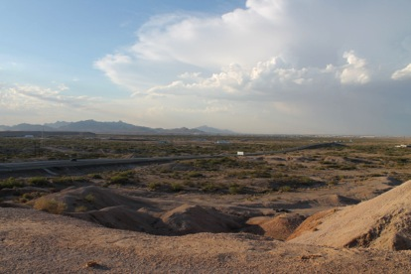

I took a taxi in the border between the United States and Mexico. Those brief 20 minutes ride will change language and will penetrated into that other world that is Ciudad Juarez, Mexico.

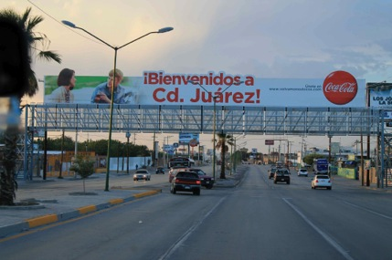
It is being said that El Paso, Texas, is the safest city in the United States. Ciudad Juarez, on the other hand, has the sad reputation of being the most violent city in the world. Between these two possible definitions, the life of many people is affected by the constant crossing, legally or illegally, from one side to the other of the border. A long corridor created by high poles shows the transit from one country into the other. Welcoming signs written in Spanish receive newcomers to a city known for the persistent effects of violence.

The ICRC, International Committee of the Red Cross and volunteers of the Mexican Red Cross received me with great enthusiasm. This project would be a pilot experience that would include visual arts and the creation of a collaborative mural as a possible liaison among youth affected by the effects of violence.
Monday: First day of work

Walls of Hope/ Ciudad Juarez, Mexico is a collaborative and community-based art project developed between June 8 -16, 2013, involving twenty six young men and women, ages 13 to 17.

This community-based mural project emerged from the support of the ICRC, International Committee of the Red Cross, facilitating the workshops “Art and Psychosocial Workshops”, volunteers from the Mexican Red Cross and the Psychological Program Opening Humanitarian Spaces, working with the artists expertise and support of the School of Art and Open Studio of Perquin, El Salvador.

America Argentina Vaquerano Romero, Claudia Verenice Flores Escolero, Rosa del Carmen Argueta, Artists/ Teachers from the School of Art in Perquin, El Salvador were teachers and facilitators of this project. Claudia Bernardi was Project Director of this collaborative mural project in Mexico.
The space where we would work was large, luminous and aired. Adjacent to a sports facility, the canvas on which the mural would be painted was 30 feet long by 6 feet high. It was attached to the peripheral walls as support. Roofing providing much needed shade was built to protect the artists from the intense sun.
The twenty-six youth affected by the effects of violence were selected to participate in this project based upon their interest in the visual arts and their desire to achieve artistic training that would allow them to replicate this project among other youth in Ciudad Juarez. Together with the participating youth, seven teachers, four volunteers from the Mexican Red Cross and 3 personnel from the ICRC making a total a group of about 40 people who were engaged in the creation of this mural.
The reception to the artists of the School of Art and Open Studio of Perquin was warm and celebratory. The first part of Monday’s workshop was based on sharing with the participants developed projects that had aspects in common with this new one about to start. We showed a power point representing: Walls of Hope/ Canada; Walls of Hope/ Belfast, Northern Ireland and Walls of Hope/ Colombia.
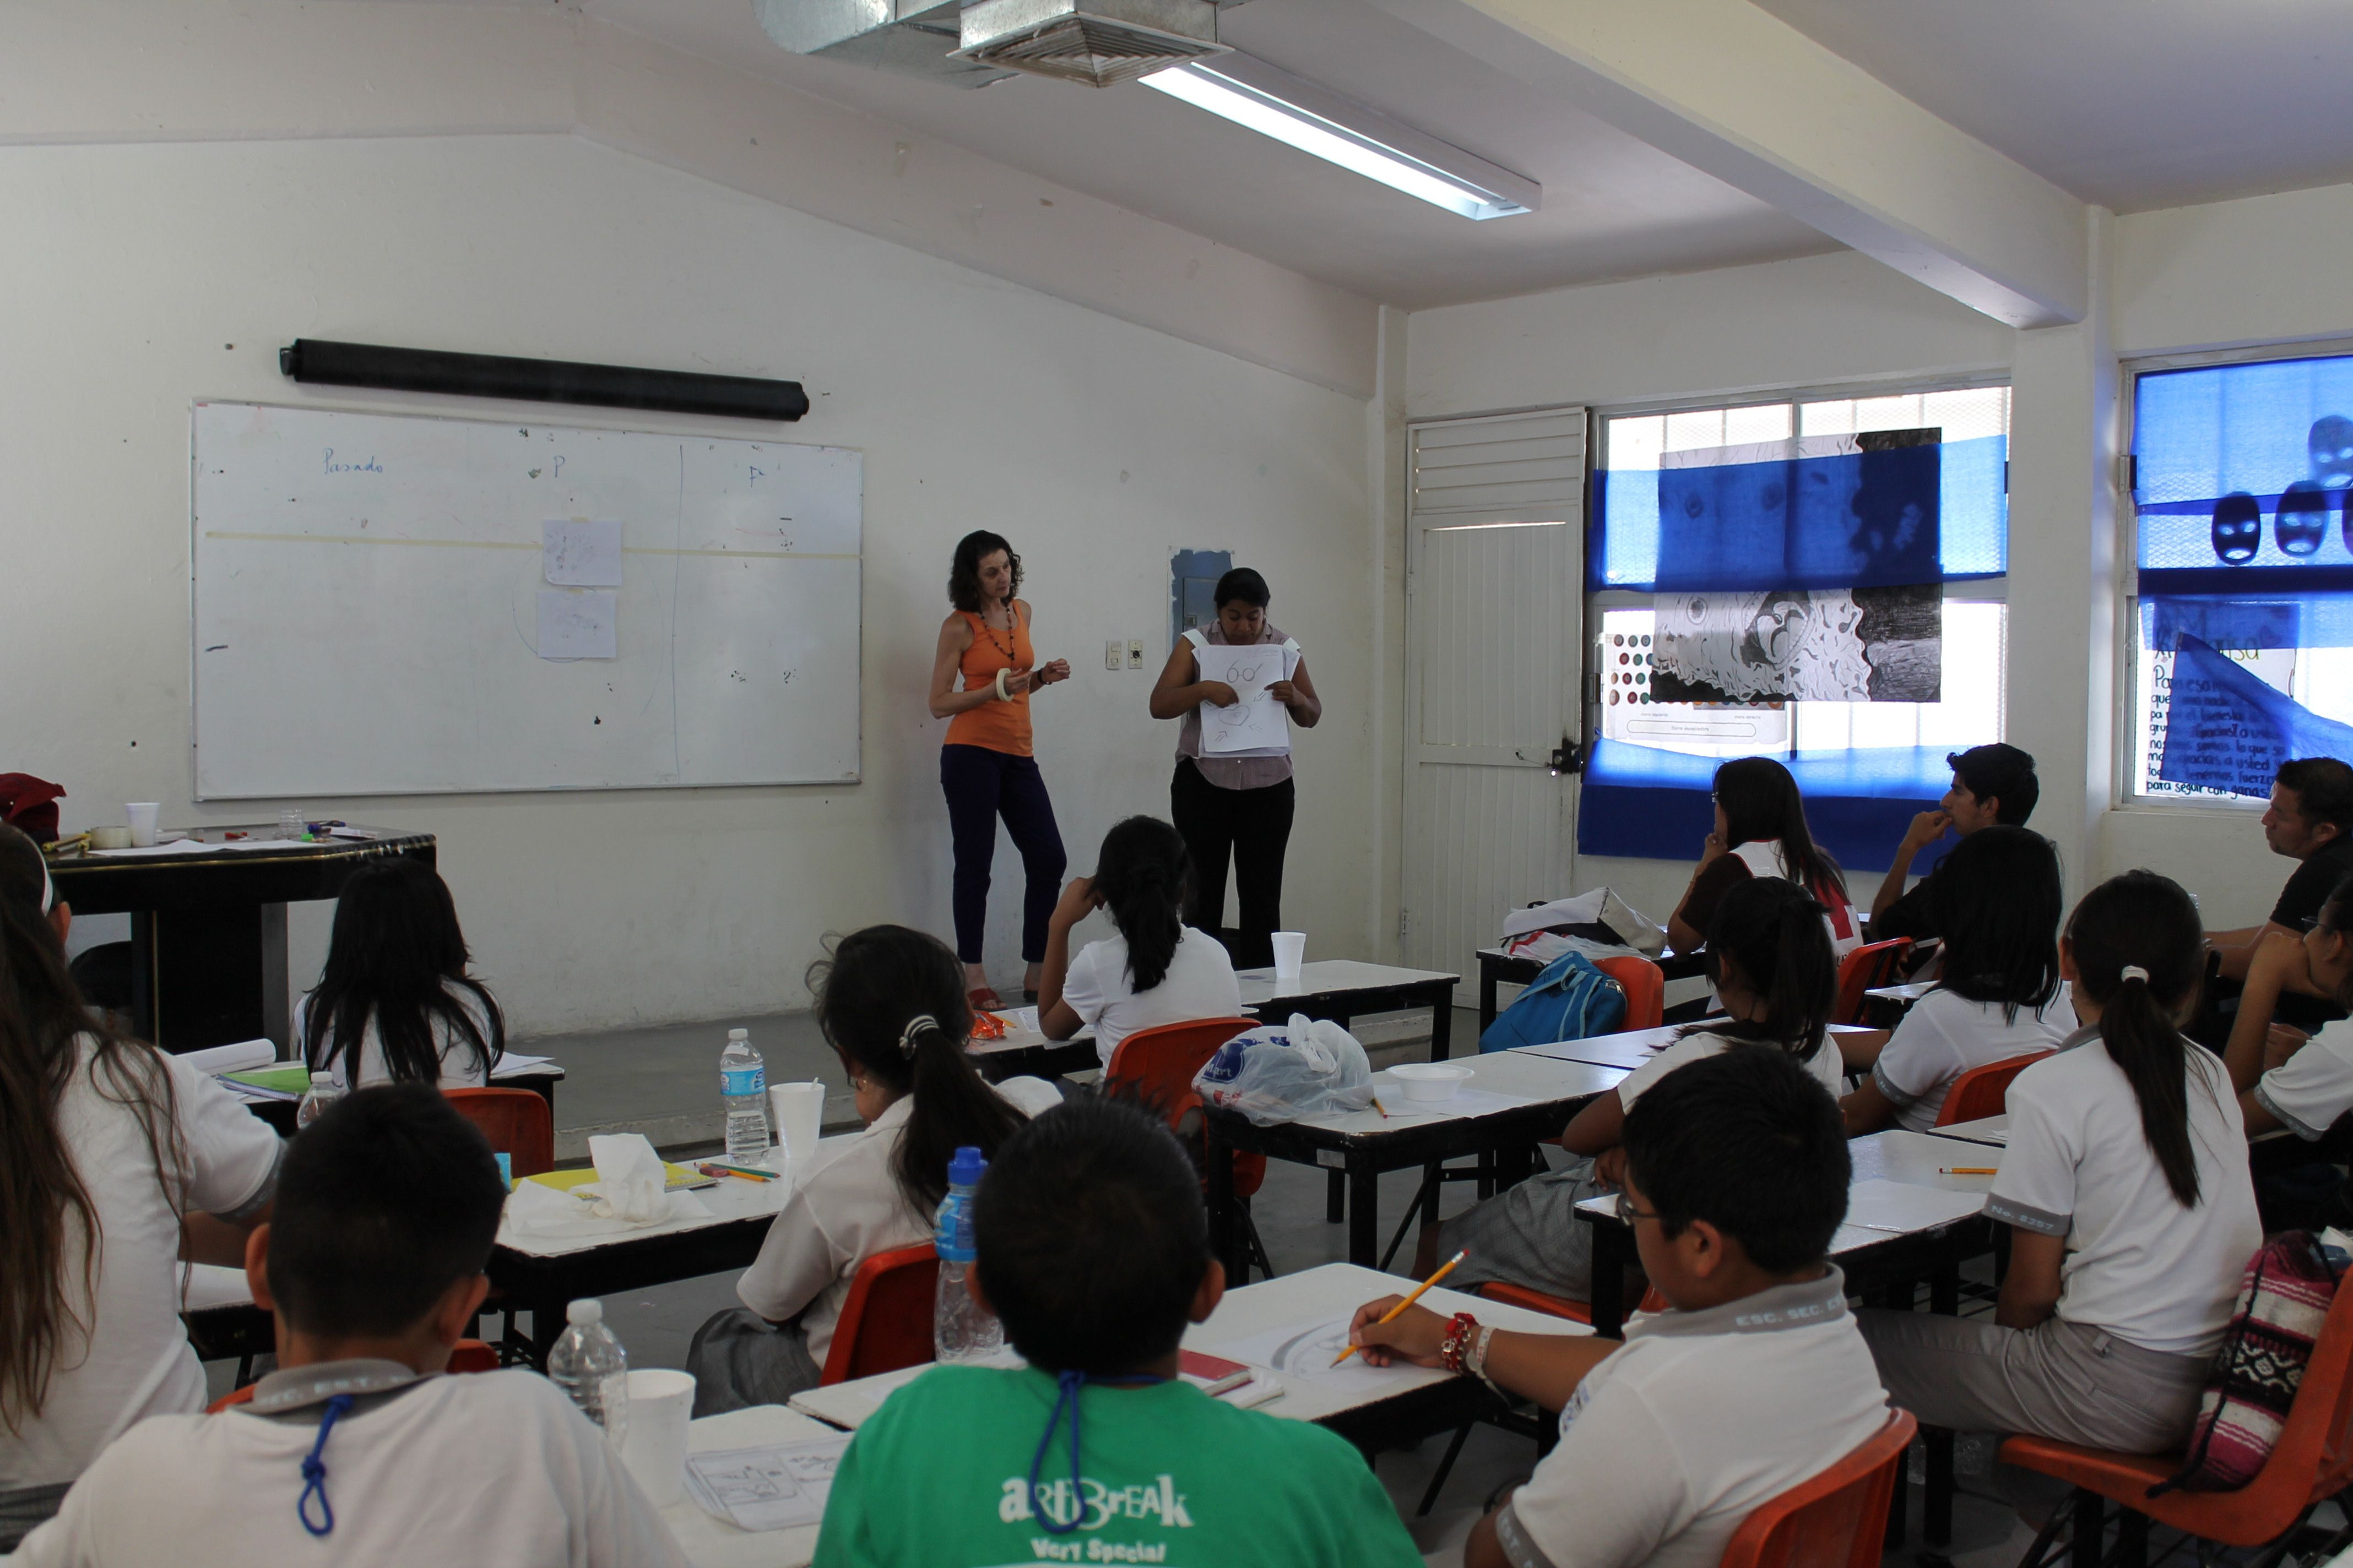
After the power point presentation concluded, we discussed which were the most relevant images that had impacted them and why?
The youth pointed out that it had been important for them to learn about acts of violence affecting other parts of the world. It was not a unique painful reality from Ciudad Juarez.
One of the participating youth asked me if I was scared working in situations where there was violence. I answered that I was always cautious and careful but on the other hand my experience had shown me that the proposal of art produced a possible coincidence, a non-violent agreement, and a meeting point of diplomacy. Not always is easy, but it is important to believe that this is possible.
I asked them:
- What is this mural going to be about?
- Which is the theme, the subject matter?
- Which is the story that you want to tell?
- What is the message that you want to deliver about who you are?
The first ideas emerged from a central image of an eye through which the reality of Ciudad Juarez could be seen. A filter of violence that affected the impression that everyone had about Ciudad Juarez and the state of Chihuahua. The youth were willing to address the effects of violence but they also wanted to imagine a different present and a less troubled future.
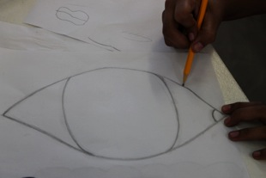
- Does this mural start in the past?
- Does it have present and future?

Ideas, sketches, thoughts started giving shape to the first steps of the composition. The drawings were visual testimonies of these young men and women who were showing their reality without restrain and with intelligence. The theme presents a vast desert that at one point was a cotton field when the Rio Bravo (Bravo River) was abundant and when the border was a way to live out of the multiplicity of commerce shared between Mexico and the United States.
The present localized in the center of the mural represents the Millennium Door, a public art piece created by Mexican artist Enrique Carbajal known as “Sebastián”. This two story-high yellow door faces the desert wishing to represent the hospitality of the people from Ciudad Juarez. It welcomes everyone in a warm lasting hug.
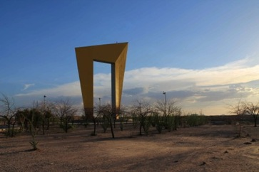
Today, the Millennium Door faces a magenta color cross inscribed with a single word: “Justice”.
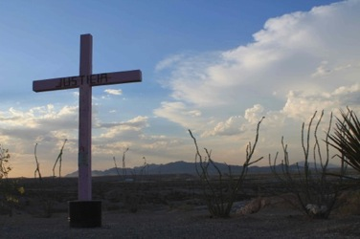
The future starts with the profile of a young woman looking towards a horizon that shows agriculture production reintroducing cotton fields coming from a distant past into a fertile future. Together with industry and commerce, the future includes the presence of another public art piece created by the same artist, “Sebastian”.
Once all drawings were shown and were discussed and once they were evaluated and agreed upon by consensus the start of the painting process started celebratory and with great enthusiasm.
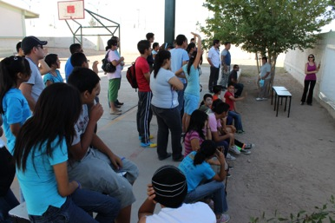

Firstly, the measuring of the actual mural image determined the size and location of the decorative band along the edges.
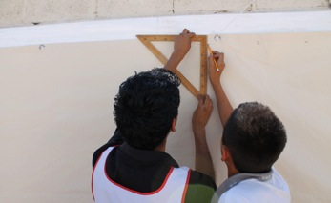
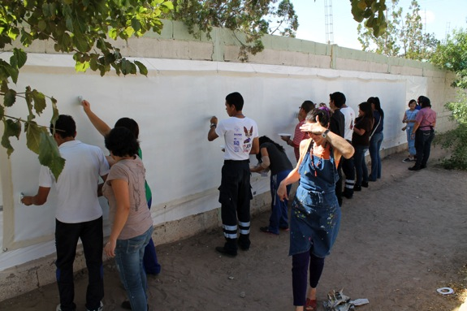
The second step was applying the gesso and the first fields of thin colors to avoid the intimidating presence of the whole field of the canvas. The youth together with their teachers, the volunteers, the ICRC participants, the School of Art in Perquin, everyone undertook the task of starting this mural without hesitation, with focus despite the intense heat and the blinding light of the desert.
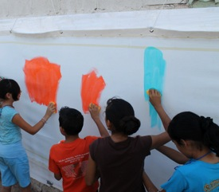

After the first day of shared work was over, I asked the participants to reflect upon what had happened to them and to the group where we shared ideas and proposals.
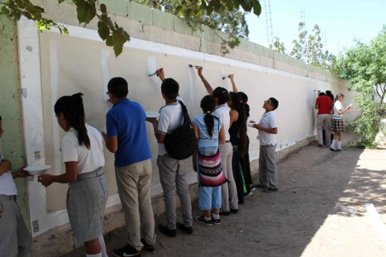
One of the young men, “A”, drew five parallel, vertical lines of the same size. He added the following sentence:
“I do not feel bigger or smaller. I feel the same as everyone else”
Tuesday: Second day of colors on the canvas.
After having arrived to consensus and reviewing the narration of the mural through the produced sketches and drawings, we started with the transporting of the images, amidst lines, shapes and composition. First with chalk and then with earth color acrylic paint, the mapping of the mural commenced, having in mind scale, location, theme, and most important images.
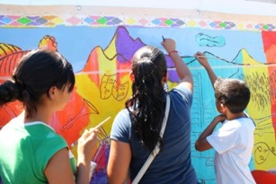

The mural was developing at an interesting rhythm.
The “present” and the “future” were evolving with no problems. The “past” had, from the beginning, many challenges. The ideas changed constantly. Ideas that had been accepted were removed; some others were replaced without being agreed upon by the majority. The images and subject matter that had been accepted by consensus, suddenly would disappear or re-localized elsewhere.
The “past”, it seemed, had several possible ways to be interpreted. Very likely, this was caused, in part, by the fact that the “past” from the perspective of youth was far closer to the present than the “past” interpreted by the older participants of the project.
This means that it appeared to be “two pasts”. The drawings on the mural kept on changing at such a speed that those that had been accepted would change and mutate so rapidly that no one was sure what the past was addressing. Or, another way to interpret this dilemma was that not everyone seemed to be willing to address the same truth from the past.
On that second day of work the reflection were painful. To arrive to consensus seemed not easy or even possible. Each participant’s desire to address the past was of paramount importance, which led to reconsidering the whole project, the reason for such a mural to be created in the first place and what story would the mural be telling. The group needed to arrive to an agreement.
On that second day of work that proposal appeared as unreachable.
It is infrequent that this kind of conflict occurs at this state of the developing of a mural. For us, artists and facilitators from the School of Art in Perquin, this was fascinating to observe. It was a humbling experience of learning about diplomacy. All the images that had been chosen demanded to be re investigated, re-evaluated and re-elucidated as to find a thread of coexistence.
Wednesday: Third day of diplomacy.
FK who is part of the ICRC is a social psychologist accustomed to work with large groups of people. He organized the start of the third day of work with a “capacitación”, a training workshop based on psychodramatic techniques in which all the participants would have the opportunity to identify on the mural that which they wanted to eliminate and that which they wanted to retain. If any part of the mural was identified as “changeable”, all participants were asked to give their opinion and propose new ideas. Said this in a different way, the process involved not only addressing that which was a conflict but, most importantly, to produce a “pro-active” contribution and a new possible suggestion.

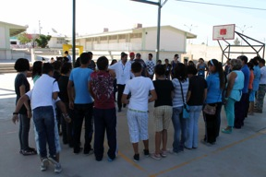
The mural belonged to everyone and it needed to be restored by everyone’s participation.
This evaluation took all morning. It was, however, crucial. The mural needed to re identify its new direction and it was imperative to decide what history it would tell.
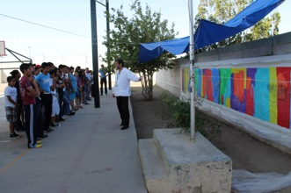
By the third day of work, the participants were comfortable handling colors, brushes, mixing hues, transparencies, identifying textures, technique, form and composition. It is never short from a miracle to see such a large people of different ages working together none of who had previous training in the arts. It is always inspiring to witness the determination, certainty and joy, that these kind of community-based art projects can achieve in a very short time.
The sky was advancing from the background into the foreground showing thick clouds and damaging winds. A sun anchors itself in the future and an immense bright moon seats in the center of the mural, facing that which needs to be changed in Ciudad Juarez today, as well as addressing that which constitutes its beauty, that which is worth keeping.
“B” who generated the idea of placing the moon, told us that the most beautiful scene that she has found in Ciudad Juarez is a night with a full moon where the light is so intense that makes the viewer confuse the night for the day.
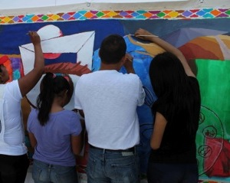

Underneath the moon, there is an eye. Inside the eye, there is a child, a toddler jailed behind bars. This is the way the youth feel when they have to accept basic rules of “security” such as not to go out at night, always being alert, never being alone, accept a curfew implanted not by local authorities but by common sense, as a survival tool.

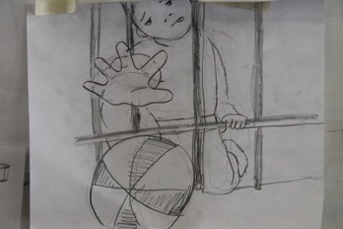
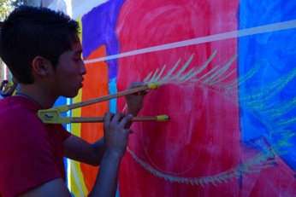
Wednesday was a day of definitions. The mural was now taking shape, the colors of the desert; the sand and earth were expanding through the entire surface of the piece.
I took a moment to observe the mural from a distance.
I had the palpable certainty that the mural was alive, that it was shining and that it had a voice.
The youth seemed beheld by passion. The decorative edges were now finished.
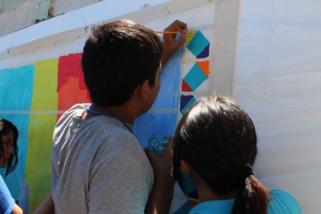

Despite the fact that the working day had started at 8 am and now it was 5 pm, no one seemed ready or willing to stop painting.
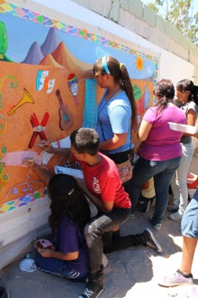
We were all falling in love with the mural.
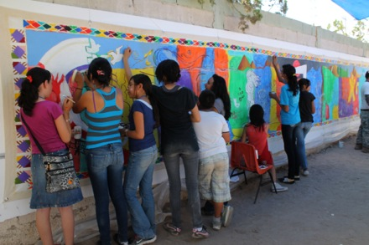

Thursday: Fourth day of consensus.
“The “past” still had challenges. The issues that had caused of disagreement were not totally dissipated. Some main themes, however, started taking shape and location. Three doves expanding from the left side of the mural emerged from the colors of a rainbow meeting a bus. The bus is coming towards the viewer. There is a man about to get into the bus, taking that definite step that will make him depart from Ciudad Juarez and initiate a trip to “who knows where?” He is carrying a small suitcase. His shoulders are curved forward, a mark of his deep sadness for this departure. This scene is repeated daily and endlessly by men and women who leave Ciudad Juarez without knowing, when or if, they would ever return.
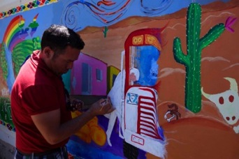
Hundreds of Mexicans, Salvadorans, Guatemalans, Hondurans cross the border every day, not in a vehicle but by foot, running desperately hoping that the “migra” would not catch them, that the US border patrols would not detain them. If they manage to cross the border it would mean a huge success. But, they still have front of them the vast desert of Texas. They will need to walk it through, that overwhelming extension of rock and sands where there are no trees or bushes to provide shelter or shade, where there will not be water for miles, where it is being said that over 12,000 people have perished trying to “make it”. The summer is scorching. The winter is not more benevolent. Being the desert the amplitude of temperatures is extreme. It can drop easily to 30 degrees below zero. The human remains of countless peoples populate the desert. They had died of hunger, dehydration, of extreme heat or punishing cold.

The young artists were moving easily from one side of the mural to the other, as if painting murals was what they had been doing all their lives.
They worked wonderfully among themselves and in collaboration with the young volunteers of the Mexican RC and the ICRC. The mural was impacting all of us. We all felt committed to it, we felt that the mural was telling a story that was needed to be told, a story that has been arrived at by consensus and we were all celebratory to see the beauty with which the ideas had been rendered.

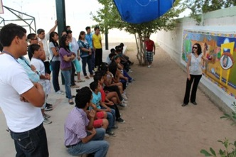
On Thursday, we needed to finalize all the decisions of the theme of the mural. From now on, there would be no space on the surface or enough time to make substantial changes. The mural needed to start talking by itself, have a life of its own.
We were listening.
It did speak! At the end of that Thursday, we left knowing that the following day would be spent painting details, last minute touches. We would celebrate the culmination of this piece.
After we cleaned for the day and we were about to leave, I heard “A” one of the youngest participants murmuring or crying.
What is the matter “A”, what happens?
Ay, Maestra! I am so happy.

Friday: Last day of the mural
The euphoria was palpable. Everyone was painting with certainty, with clear intention, there were no more changes and even the “past” had arrived to an agreement. The past enters the mural “stage left” with a sharp perspective that shows a street of inhabited houses. In Ciudad Juarez there are entire neighborhoods that had been abandoned where few people still remain. No one walks on the streets, there is no public transportation, and there are neither families nor schools. These are ghost towns produced by the exodus towards the North.
Thursday night had brought some rain, which brought a needed fresh air to settle during this last day of work. The brushes danced rapidly, the colors were mixed one more time, the artists were attentive to the last fine lines, small details and last minute outline contrasts.
Everyone who stopped by and saw the results asked when the next mural was going to be painted? It is always hopeful to start thinking about a new project.
Members of the Mexican RC, the ICRC, the many people who came from different parts of the city were showing their admiration and complemented the young artists. They listened feeling proud of what they had created.
One of the young artists, “B”, said:
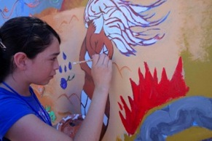
“It is not that common that anyone say anything positive about the youth of Ciudad Juarez. I am very glad that they can see what we are capable of doing”
Other comment:
“This is the most beautiful thing I have done since I was born”
The past defines the desert with three cacti of nopales. It transits towards the present with three magenta crosses, buried in the same desert that moves towards the future turning it into a fertile garden and a land apt for agriculture.
Ciudad Juarez is re mapped with broad new possibilities.
Which name shall this mural have? By consensus, the mural was christened:
“Juarez is not the way it has been defined but as the way you can live it”
Photographs, happiness, celebration, laughter, hopes to continue painting, hugs, some tears, tiredness, pride, no one wanted to leave!
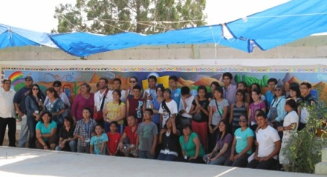
We looked at the finished mural and we could sense electricity that connected all of us in admiration of what we have been able to achieve. In a week of work this group of participants had given life to a 30 feet long history. This history had become from ideas, conflicts, proposals and it was ending now in coincidences and mutual appreciation.
The mural was a total success. Each of us had given the best of ourselves. We all learned from one another, we all had to be flexible at one point. We had to exercise one of the most demanding human tasks: empathy.
Saturday: Inauguration:
Dressed fancily the young artists were ready to present our beloved mural to families, friends and guests. Local authorities, supporters and even pass byers came to celebrate this great success.
There were words of appreciation and thanks. It was a moment in which each and all the young artists were acknowledged. In their shining faces and their young and ready bodies, one could imagine a different future for Ciudad Juarez.
When it was my turn to speak, I said:
“You are right. What is being said outside Ciudad Juarez is painful and scary. My Salvadoran friends and I are thankful for this learning and moving experience. We have learned to see Juarez through your eyes, through your projects and your hopes. For that we thank you.”
I did not say this at the time, but I am convinced of it after few months since the project was completed.
“The world can become a better, a more just place because all of you are in it and you will be able to change history with the tenacity of your dreams”.

Dear Young artists of Ciudad Juarez: THANK YOU VERY MUCH!!!!

THE MURAL: The Past
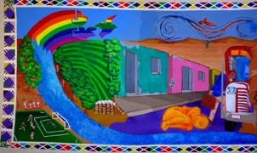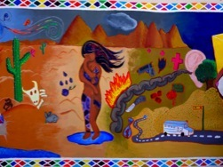
The mural starts with a sports field. A fast flowing river and its mighty waters for irrigation made it possible that the cotton production of Ciudad Juarez became its pride and a resource of prosperity. Accumulated bags containing first-degree cotton waited to be exported. The prosperity stops abruptly with the presentation of abandoned houses showing not only the building’s deterioration but also the reality of a punished city.
A rainbow turns into wild winds sculpting the desert of Juarez. The bus is taking away one more immigrant, as so many, every day, every month, every year. It is possible to predict that very few of them would return.

In the main road of this scene there is a figure on the ground not identified either as male or female. Its enormous fragility proposes a question: Is this person sleeping or dead? Is the person waiting for this bus or for another one? Is this person coming from far away? Where is now going to?
The past is populated by questions that no one dares to ask and no one answers.
The nopales are flowering. The desert expands implacably.
There is a suffering woman. She has been harmed and she has marks on her body and pain in her soul.

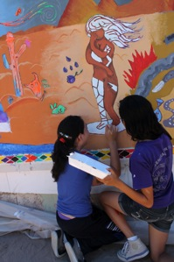
Precariously standing on a small pond of blue water, she wants to think that the future could be better. Behind her, there are three magenta crosses that identify the location of the finding of women who died violently. The crosses await a less tragic future.
To the right of the suffering woman, there is a chain coming out of an ear that only hears the catastrophes that take place in Ciudad Juarez. The national and international media who only address violence and its effects has in part, created the reputation of this city.

The Present
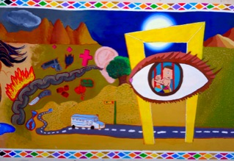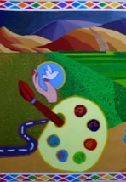

A large wonderful moon illuminates the scene from behind the Millennium Door. There is an eye through which the reality of the young people from Juarez filtrates. Their hopes transit from the past into the future. The present alludes to a public transportation system that is insecure, insufficient and unreliable. It could or it should transform into an urban transportation system that would be frequent, safe and available to everyone who needs to travel from within this broad and dispersed Mexican city.
The path from the present into the future is marked by a painter’s pallet. Each color depicted within it shows what the young people of Juarez hope for: art, music, sports, community based projects. A creative hand will always be ready to render life and hopes.

The Future
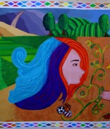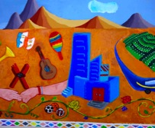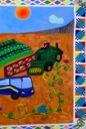
A young woman portrayed with abundant colorful hair looks directly to a possible future of music and solidarity. Two hands meet to celebrate sports, art and the re commencement of local industry which will lead to the creation of new jobs. If this may be obtainable, it would mean that the citizens of Ciudad Juarez would not need to opt for migration and exodus.
Cotton would be, again, a main crop of local agriculture, connecting the past to the future and reaffirming an independent, possible and durable economy.
Public transportation would be improved safely taking young people from one extreme of the state of Chihuahua to the other. They will disseminate what they had learned in this project: that everything is possible, that all changes start with a fervent desire and a commitment to hope.
The desert is dressed with flowers, with color and limitless new option.
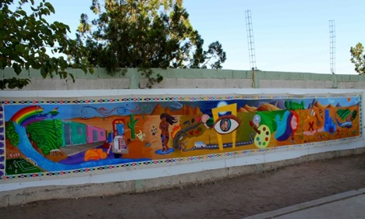

Reflections:
Each project is filled with challenges, with a learning process, with an incalculable amount of details to consider and with accomplishments.
The last day of this mural project in Ciudad Juarez, FK asked me what was different of this mural project from others created in Latin America?
The presence of the desert.
Until this project, my Salvadoran colleagues and I have worked in parts of the world where green are predominant, thick vegetation, forest and cornfields define the geography.
In this mural, the desert is a protagonist and with it, one can feel the helplessness of inconceivable extensions, horizons that melt in the torrid heat or in the disarming cold. Nothing in the desert is easy or benevolent. Everything is painful and alarming.
We have learned a lot from the people from the desert. We have learned from the twenty-six youth with whom we painted this mural and from everyone who participated in this project. We have learned that the many vicissitudes are also the beauty of this story. Those who remain in Ciudad Juarez dream with a better future for all, with a reality that will escape the current definition of violence and insecurity.
Those who remain in Ciudad Juarez learn how to love silently and without strident gestures.
In one of the last conversations we, the four artists teachers form the School of Art in Perquin shared, we wondered:
“Would we return?”
Unanimously we answered: “Yes, we would”.
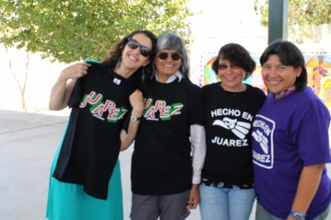

Thank you Ciudad Juarez, for welcoming this proposal of art!
Until the next mural project we will remember each and all of the young artists from whom we have learned so much and whom we love dearly.
Claudia Bernardi
Berkeley, June 27, 2013.

