BUILDING FUTURES

WALLS OF HOPE/ THE SCHOOL OF ART AND OPEN STUDIO OF PERQUIN, MORAZAN, EL SALVADOR

WALLS OF HOPE/ The School of Art and Open Studio of Perquin founded in March 2005 is a community-based and collaborative project of art, education, human rights, conflict resolution and diplomacy.

Pedagogically and philosophically, the school is designed to respond to the demands and requests of the communities of El Salvador developing educational and cultural projects using art as a way to retain, protect and disseminate historic memory. Since 2007, WALLS OF HOPE has traveled the world implementing similar strategies of art and activism in Latin America and Europe.

This “on line” invitation is to support our work for one year, September 2013-2014, by making a tax-deductible donation by visiting our web page:

www.wallsofhope.org

Your donation will be processed to us through our fiscal sponsor:
Intersection for the Arts
Address: 925 Mission St #109, San Francisco, CA 94103
Phone:(415) 626-2787

Any contribution that you can provide will be of enormous help making it possible that projects as the ones you will find in this enclosed document will continue to exist and expand all over the world.

Thank You!

Founder, Artistic Director: Claudia Bernardi

Artists/ Teachers: Claudia Verenice Flores Escolero
America Argentina Vaquerano
Rosa del Carmen Argueta
Amílcar Varela

2012-2013 Report

The Following document contains a brief description of the most recent local and international projects created in 2012 and 2013 (as thus far)
WALLS OF HOPE/ The School of Art of Perquin is an art initiative run by four local Salvadoran artists/ teachers who direct the school: America Argentina Vaquerano, Claudia Verenice Flores Escolero, Rosa del Carmen Argueta, and Amilcar Varela working in collaboration with Claudia Bernardi, artist and educator from Argentina.
Public art projects, site- specific interventions, mural projects, weekly classes in painting, drawing, sculpture, wood sculpture, special classes focused on the use of recycle material and the respect and protection of the environment are part of the curricula created and developed each year.The School of Art and Open Studio of Perquin serves children, youth, adults and the elderly welcoming all members of the community regardless their political or religious affiliation.
Since 2007, The School of Art and Open Studio of Perquin/ Walls of Hope has become an international art and human rights project of education.The strategies and methodology of collaborative and community based art praxis created, developed and facilitated in Perquin have been implanted in the following countries.

INTERNATIONAL PROJECTS:

Antigua, Guatemala, February 2007
Mural Project created by indigenous survivors of massacres of Ixcan, Ixil, Nebaj, Chimaltenango and Chajul.

Sacramento, California, US, October- December 2007
Mural Project and Video Documentary created by African American and Latino youth at inter-city Sacramento High School.

Guatemala City, January 2008
Mural Project created by indigenous survivors of massacres in Ixcan and Quiche working collaboratively with Human Right advocates members of ECAP, Equipo Comunitario de Acción Psicosocial.

Toronto, Canada, April- May 2008
Walls of Hope: Installation: Sculptures, Paintings, Video, Dance, Theatre, Spoken Word created by recent refugee youth and youth at risk.

Huehuetenango, Guatemala, August 2008
Mural project created by indigenous women survivors of sexual violence during the armed conflict
Cobán, Guatemala, February 2009
Paper sculpture project created by indigenous women survivors of sexual violence and sexual slavery during the armed conflict.

Rabinal, Guatemala, February 2009
Mural Project created by indigenous survivors of torture and survivors of the massacres of Rabinal, Plan de Sánchez and Rio Negro.

Cocorná, Colombia, August, 2009
Mural Project created with members of the Association of Victims of Violence and Forced Displacement of Cocorná, Antioquia.

Panzós, Guatemala, June- July 2010
Mural Project created by the survivors of the massacre of Panzos, Alta Verapaz, Thanks to a NALAC Transnational Cultural Remittances grant.

Belfast, Northern Ireland, September 2011
Collaborative and community based mural project created by Catholic and Protestant children on the Ardoine Road, west Belfast during the Ardoyne riots.

Permeable Borders, Waynesboro, Virginia, May 2012
Collaborate and community based project created by Mary Baldwin College students and faculty, 50 4th and 5Th grade children from Wenonah Elementary School, 20 Latino children from Casa la Amistad and residents of a housing project in Waynesboro, West Virginia.

Monthey, Switzerland, June 2012
Mural Project created by 93 refugee, migrant and forced exiled people from 25 different communities from Latin America, Africa and Eastern Europe.

Threads of History, Staunton, Virginia, May 2013
Mural Project created by African American elders in collaboration with students and faculty from Mary Baldwin College

Ciudad Juarez, Mexico, June 2013
Mural Project created by 26 youth, ages 13 to 17, affected by the consequences of violence.

Walls of Hope/ The School of Art in Perquin creates bridges of collaboration with local agencies using art as a contribution to community building enforcing leadership roles among the participants.

Proposal 2013-2014: BUILDING FUTURES.

This request for funding is to continue designing, creating and developing art education classes, public art projects, special workshops, national and international partnerships expanding from Perquin to areas of the North of Morazán and to the rest of Latin America and Europe.

This proposal focuses on two parts: Local and International.

LOCAL:

In 2012 and 2013 efforts were made to create three new workshops:

- Wood sculpture classes designed to train children and youth in the demanding craft of building furniture, developing skills that may provide them with work opportunities in the future.

The exodus of people from El Salvador to the US has not diminished. Rather, it has increased in the last 5 years. Many children and young adults are left behind in Perquin, when their parents and family members opt for economic exile. As an average, these children and young men and women will not see their parents for more than ten years.

In the School of Art in Perquin, we are committed to create art classes and workshops that may give them tools to work and survive independently.

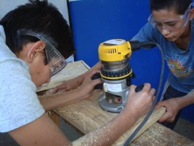

Learning how to use wood tools

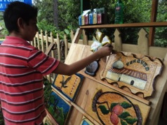

Nahun applying final varnish on his wood piece
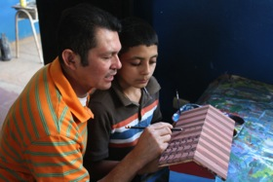

Don Amilcar Varela teaching a wood sculptures class

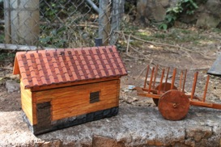

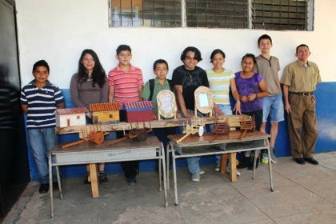

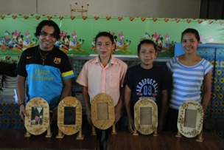

Completed wood sculpture projects

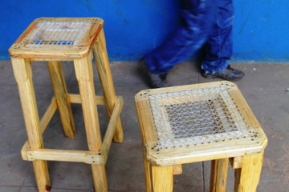

Completed furniture projects

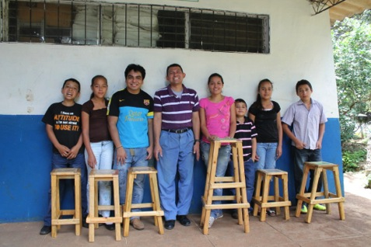

List of completed Wood sculpture and wood furniture projects in 2012-2013

- Wood carving landscapes
- Safety Box in the shape of a house.
- Carved Portrait frames.
- Wood wagon
- High stool with woven mesh seat

- Workshops with recycled materials created by women and girls in the Perquin and La Tejera.

Plastic bags, plastic bottles, plastic debris of varied kinds is a constant threatto the environment and to the health of the people of Morazán. Despite the frequent efforts of “cleaning campaigns” the plastics seem to be deposited from one place into the other without finding a rewarding and environmentally safe solution.

The artists/ teachers from the School of Art in Perquin, have placed paramount effort in designing workshops with recycled plastic materials, mostly bottles and plastic bags.

The results are astonishing. The transformation of discarded material into the creation of new, usable and beautiful objects, is modifying the environment on the North of Morazán.

Neighboring communities have requested similar workshops to train youth to learn and carry on similar environmental conscious projects.

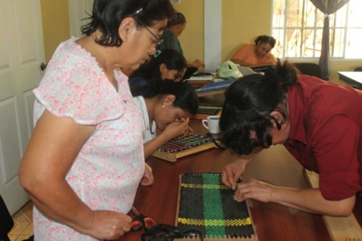

Rosa del Carmen assists with the creation of a recycle textile made of garbage bags

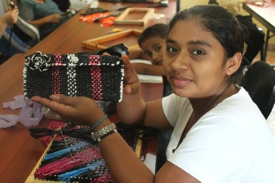

Showing her final purse created exclusively with recycled plastic garbage bags.

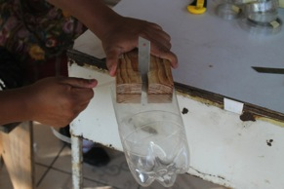

Cutting recycled plastic bottles to create handbags

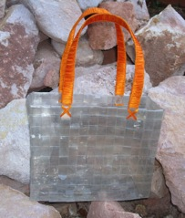

Handbag created with recycled plastic bottles

Recycled paper

Inspired in the success of the recycled plastic workshops, new workshops of recycled paper were created for women and girls in Perquin and La Tejera.

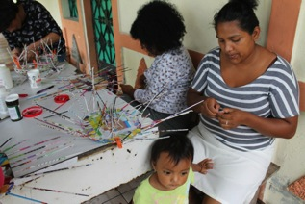

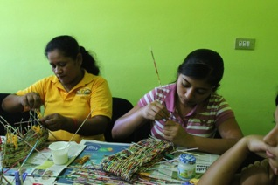

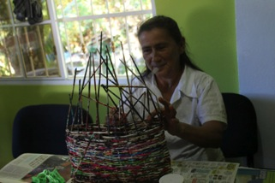

- Art Classes and Workshops

Art classes of painting, drawing, perspective, portrait painting and soft sculpture are developed weekly for children and youth.

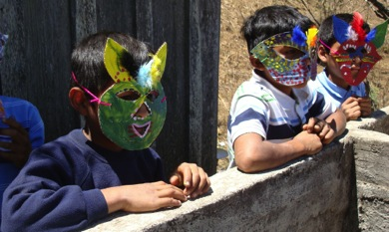

Mask project created with recycled painted cardboard and recycled paper

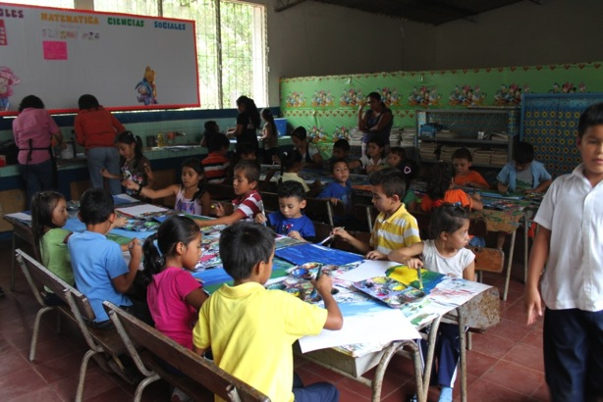

Painting classes for children

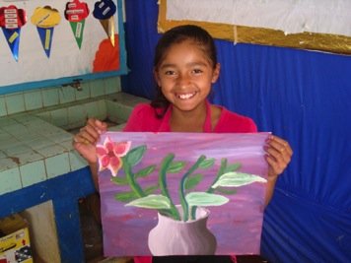

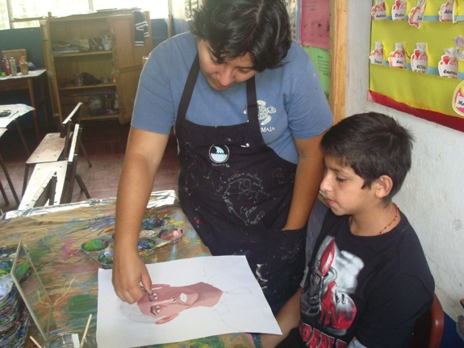

Verenice assists Nahum in the development of his self-portrait

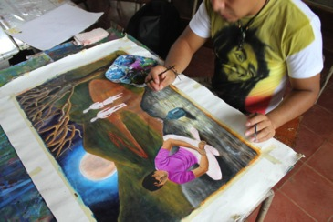

Painting classes for youth

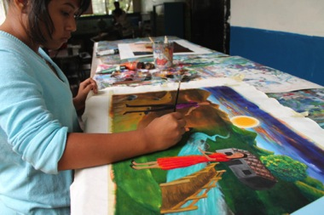

Drawing and Painting classes take place weekly in Perquin and Arambala, serving an average of 60 participants per week, ages between 4 and 12 years old. Children with special needs have been successfully integrated in these classes.

In March and April 2013, The University Matias Delgado invited the four-artists/ teachers of our school to give a series of lectures sharing the strategies of education and community art praxis.

Two exhibitions featuring the artwork created by young artists of Perquin students of the School of Art were presented in Staunton, Virginia and in Monthey, Switzerland.

L’ART, OUTIL DE PAIX ET D’ESPOIR

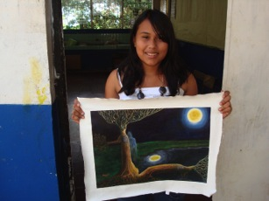
EXPOSITION
Peintures et photographies

L’exposition « L’Art, outil de paix et d’espoir » présente une vingtaine de toiles d’élèves et d’enseignantes de l’Ecole d’Art et Atelier Ouvert de Perquín, petite ville du Salvador d’environ 3'000 habitants. Perquín est la capitale de l’Etat de Morazán, une région dévastée par la guerre civile qui a frappé le pays entre 1980 et 1992.

Les élèves de cette école, qui ont entre 12 et 15 ans, s’inspirent des paysages urbains et de la vie quotidienne des habitants de leur ville. On trouve dans leurs œuvres l’atmosphère de ces localités de province qui se vident d’une partie de leur population. La pauvreté, l’absence de plans de redistribution de la terre et le développement inquiétant d’une économie liée au trafic de drogues pousse en effet beaucoup de jeunes à l’exode vers la capitale, San Salvador, et surtout vers les Etats-Unis, où ils espèrent trouver du travail pour aider leurs familles restées au pays. Malgré la paix rétablie, la vie après le conflit reste difficile.

D’autres œuvres sont plus intimistes : les jeunes artistes explorent leur monde intérieur, dévoilant leurs préoccupations personnelles, leurs soucis et leurs aspirations.

Les travaux des trois enseignantes sont ancrés dans leur vécu et leur engagement social. Y sont présents les thèmes de l’exil, de la condition féminine, des enfants et des personnes âgées vivant en milieu rural.

En parallèle, une vingtaine de photographies amateurs permettront de découvrir les différentes étapes de la confection de murs de l’espoir dans divers pays d’Amérique Latine.

L’ART COMME OUTIL
DE MÉMOIRE, DE VÉRITÉ ET D’ESPOIR

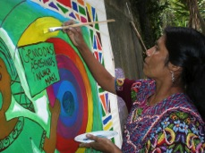

L’expérience de
l’Ecole d’Art et Atelier Ouvert de Perquín en République du Salvador
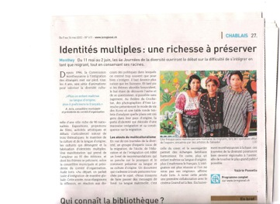

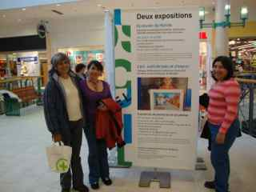

- Murals in El Salvador:

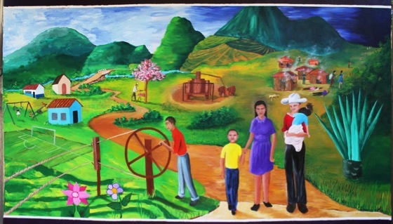

Commemorative mural of the massacre of La Joya, petitioned by the families of the victims and the Secretary of Culture of the North of Morazán.

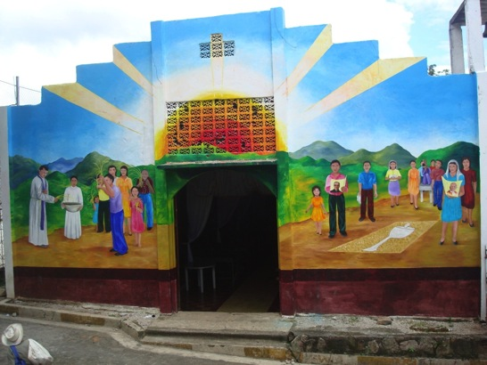

Mural in the front of the Catholic Church of Perquin, Morazán, El Salvador

To demonstrate the role that art plays in creating bridges of diplomacy in communities in conflict, these two murals are vivid examples of successful attempts and effective solutions.

A mural painted in 1992 in the façade of the Church of Perquin with a prominent image of Archbishop Romero was defaced in 1993 by polarizing Catholic groups.
For conservative Catholics, Archbishop Romero signifies a leftist ideology and an alliance to the FMLN, the leftists guerrilla that fought the war.

For liberal Catholics, Archbishop Romero signifies an inspiration, the “Voice of the Voiceless” and a deep commitment to social activism.

Since 1993 until 2013, an acrid debate appeared to make it impossible to come to terms and arrive to coincidences regarding the creation of a new mural for the church. The artists and teachers of the School of Art, with agonizing patience, organized workshops and community meetings that had as a mandate the finding of a subject matter accepted by a majority.

It was arduous but ultimately possible. Both groups accepted that the mural would address the preparation and rituals of Easter as they were practiced when the elders were children. That means, before the war. The blessing of palms, the creation of the “alfombras” (rugs) made with flowers, earth and natural pigments that is tradition in the North of Morazán. As a diplomatic arrangement, both groups accepted the presence of a small portrait of Archbishop Romero and a small portrait of the Pope, as a balance between the Conservative Church of Rome and Liberation Theology ideology. (It must be clarified that this conversation and the outcome of the project took place before Argentine Pope Francisco was elected Pope)

The mural commemoratingthe massacre at La Joya, Morazán, was equally charged with antagonism.The massacre of La Joya took place on December 1981, few days after the massacre at El Mozote. Sadly, like in El Mozote, there are very few survivors.

The creation of the mural in La Joya brought forward the possibility of dialogue,which appeared impossible. People of varied belief systems and political affiliations came together to paint this mural in recordation of the victims that perished in 1981, mostly women, elderly and children.

INTERNATIONAL MURALS:

In 2011, a mural was painted by Catholic and Protestant children affected by the eruption of the Ardoyne riots in Belfast, Northern Ireland. The children worked in two different locations: one was an exterior mural at Holy Cross, Catholic School Holy and the other was an interior mural at Wheatfield Protestant School.
This project was conceptualized as creating“the same mural with two homes”.The outcome was remarkable and hugely successful, eroding the traditional concept of a site-specific mural and bringing dialogue and integration among children born in a torn apart society that suffers violence and political and religious confrontation for many centuries.

Permeable Borders/ A possible Map for a World in Motionwas implanted in 2012 as a collaborative and community-based project creating murals in different parts of the world documenting personal and communal histories of people affected by violence, human rights violations and forced exiles.

Permeable Borders, Waynesboro, Virginia:
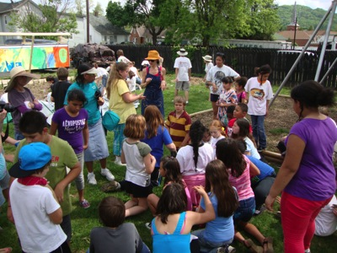

Fifty children from 4th and 5th grades from Whenona Elementary School in Waynesboro, in collaboration with

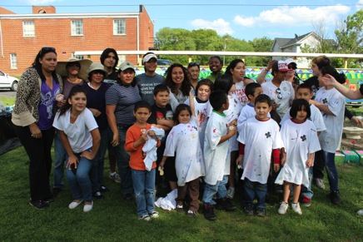

Twenty children from Casa de Amistad, an afterschool program, serving Latino youth, Tanya Hardy and the Tenant's Apartment at 260 N Commerce Avenue,
the Latin American community living today in the vicinity of Staunton, Virginia,

in collaboration with fifteen students from Mary Baldwin and Professors Marlena Hobson, Allan Moye, Steve Grande andThe School of Art and Open Studio of Perquin, El Salvador, painted a double faced mural 80 feet long and 3,5 feet high, and created a garden project between April 28 and May 15, 2012.

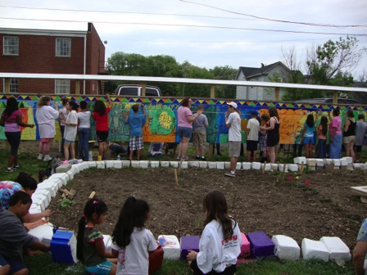

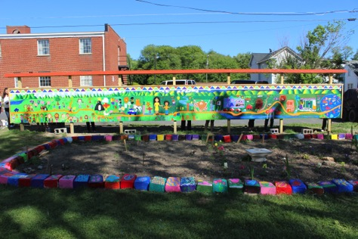

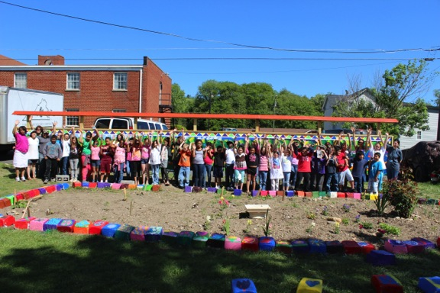

Mur de l’ Espoir, Monthey, Switzerland, May 2012

Mural project painted by 93 refugees, asylum seekers and forced exiled people from 25 different countries from Latina America, Eastern Europe, Africa and Asia.

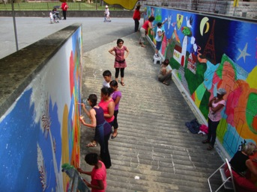

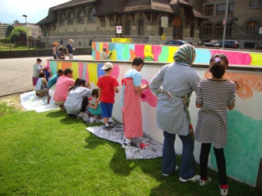

Participants from Iraq, Kurdistan, Libya, Venezuela and Argentina

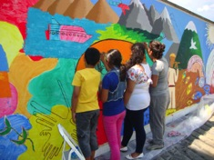

Diana and her family from Peru

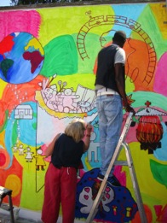

Angelika from Germany, Hadhir from Senegal

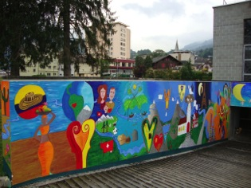

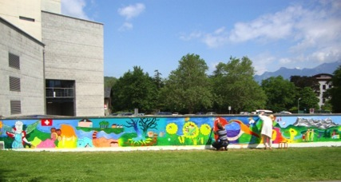

Threads of History / Staunton, Virginia, May 2013

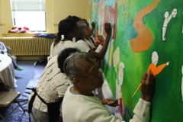

Ms. Deming. Art Teacher in 1966, 84 years old today.

Fifteen students and faculty, Dr. Marlena Hobson, Allan Moyé and Dr. Steve Grande from Mary Baldwin College, the community of 40 African American elders, Alumni from Booker T. Washington Community Center in Staunton, West Virginia, in collaboration with The School of Art in Perquin painted a traveling mural and two small in-site murals depicting the history of “integration” from the perspective of the African American Alumni and Professors who were faculty members and students in 1966 when they were forced to relocate from the Booker T. Washington high school into the “all white” Robert E. Lee high school.
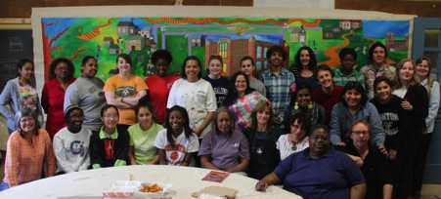

Thread of History Artists

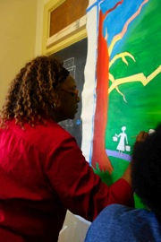

Lalaura, Alum from Booker T Washington high school
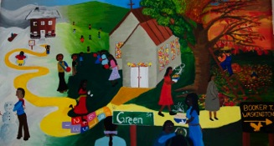

Seasons Mural

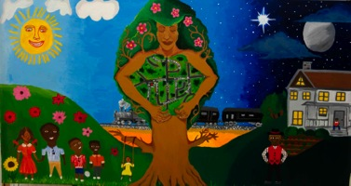

Matriarch Mural

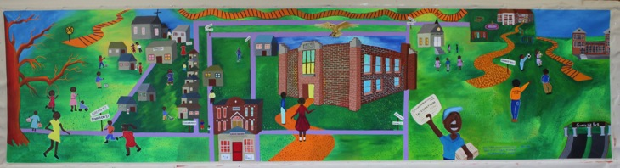

Threads of History/ Hilos de Historia Mural

Threads of History will continue during 2013- 2014 bridging people from Germany to Switzerland, from El Salvador to Ciudad Juarez, Mexico and from Mexico to Argentina.
In 2012, The School of Art and Open Studio of Perquin has worked in partnership withAmnesty International, the Haute Ecole Specialisé de Suisse Occidental HES.SO and most recently with The International Committee of the Red Cross, ICRC.
From September 6 to 15, 2013, Walls of Hope has been invited to conduct a mural project during the Internationale Woche in Osnabrück/ International Week in Osnabrück. The Department of Social Work at the University of Osnabrück proposed a mural project created by students and refugee women from Eastern Europe, some of whom are survivors of the massacre of Srebrenica, Bosnia.

Amnesty International Fribourg, Switzerland invited the School of Art and Open Studio of Perquin to create a mural project with refugees and asylum seekers from September 25 to 30 bringing together participants associated with l’Africanum, LivrEchange, Passerelles, Espace Femmes, la Croix-Rouge Fribourgeoise, Caritas-Suisse, le Club Unesco.

Ciudad Juarez, Mexico, June 2013.

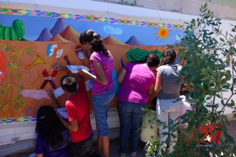

In June of 2013, The School of Art in Perquin designed, created and facilitated a mural project with youth, ages 13 to 17 in Ciudad Juarez, Chihuahua, Mexico, affected by the consequences of violence.

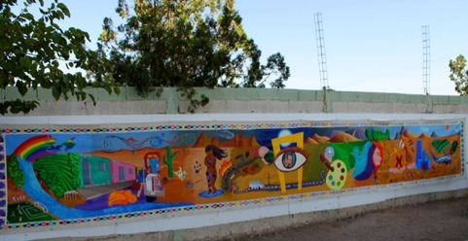

Wish List:

The most desired wish is to have a building of our own. We have a group of dear architect and builders friends who are willing to build us a school if we can get the funds to buy the land.

Price of a lot of land in Perquin, $ 40,000

For this year’s school activities we need:

- Art materials, including mural paints, water based acrylic paints, water colors, color pencils and markers
- Brushes/ glue/ erasers/ measuring tape/ masking tape.
- Papers and blocks
- Art books.
- A Mac Pro computer.
- A Photographic Camera.
- Printing cartridges.
- Wood carving tools
- Wood working equipment
- Wood, nails, varnishes, wood glue, etc.
- Google, gloves and safety materials for students and teachers.

THANK YOU VERY MUCH FOR CONSIDERING SUPPORTING WALLS OF HOPE/ SCHOOL OF ART AND OPEN STUDIO OF PERQUIN, EL SALVADOR.

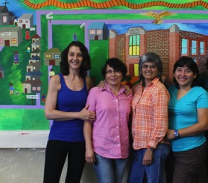

With kindest regards,
Claudia Bernardi, Rosa del Carmen Argueta, America Argentina Vaquerano,
Claudia Verenice Flores Escolero.

http://facebook.com/wperquin www.wallsofhope.org

